project proposal

Code with WIE Let’s Rise Together

Content

1. Project Title
2. Problem Description
3. Proposed Solution
4. List of Key Features and High level architecture diagram
5. Humanitarian aspect of the project
6. Team Details

1. Project Title

Maintain your fitness due to COVID-19 and stay at home

2. Problem Description

Today all are facing COVID-19 virus. Not only Sri Lankans but also all counties are facing that problem. Some countries were putting curfews to control this virus. In this curfew period citizens must pay attention to their nutrition because they can't go outside and people can't go to gymnasium to maintain their fitness. Some people do exercises as a habit in their day to day life. People do not get exercise, the result of that is that they become fat and they face many problems. Some people become diabetes patients. Some are becoming heart disease patients. Some are increasing their diseases.

People are trapped at home. People can't buy Vegetables fruits and nutritional food in the market. They can't get a nutritional Diet. Especially children and older people. The result of that is that they will face many Complications.

People can't go out to meet his or her Doctor to get nutritional advice. Sometimes they can't contact a doctor. Then they haven't got any advice or idea how to maintain their fitness. The result of that is some are become Overweight and some are become Underweight. Both are very harmful for the body. In covid-19 period people should protect their mental Integrity as well as their fitness of body.

3. Proposed Solution

When we meet a doctor we should use face masks but can't give it 100% protection. The best thing is we reduce our outgoing travels. Can get your height and weight at home and take an idea of your status. It is good for you.

The solution to this matter is we create a Web page for our problem. We get a height and weight from a person. Then we put it into a formula.

f=Weight/[Height]2

We Called is as a BMI (Body Mass Index) Value

Person should input his weight in kg and Height in m.

Then we Calculate and get f

Next we give him status as Overweight, Normal Range or Underweight.

Continually we get in week by week.

We create a graph and we can get an idea about that person's nutrition.

Finally we can give him advice about his nutrition according to this chart.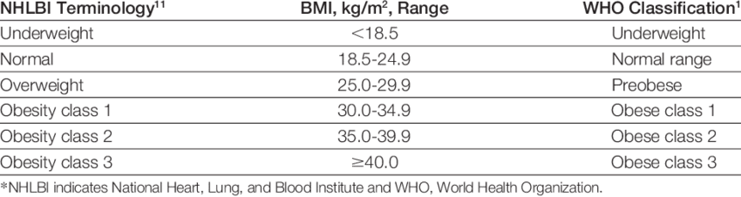

Sometimes he was overweight and weekly it was continually high, then we can give him advice and give him a nutrition diet. Sometimes he was in Normal range and he was going to Overweight. Then he does many exercises to maintain his fitness. Some person is going to Underweight, it is not good

Another benefit is this Website is free and easily any person can handle it. Then he or she won't pay any channeling cost. They don't go to meet a doctor. They can get advice on staying at their home. Not only that covid-19 period after the virus period can they save their time and money.

4. List of Key Features and High level architecture diagram

* + Clients can create an account for free.
  + We give medical advice for free.
  + Clients can get advice all over 24 hours.
  + Our website is attractive.
  + We keep records weekly.
  + Clients can study theirBMI value variance in themselves through the graph which is created by us to get details of clients weekly.
  + This website is not taken much time to load because of that is simple one.
  + New information can be gathered due to the update of the site on nutrition.
  + Anyone in the world can get the services.

High level architecture diagram

Adminstration Tool

Administration Layer

API

Documentation

Management

Administration

Client

Recommender Server

Database

Layer

Application

Layer

API

Layer

Client Layer

Client

Application 1

**DB (Actions)**

Online Recommender

Services

Web Service API

Client

Application 2

Action Services

**DB (Association Rules)**

Offline Recommender

Services

Client

Application 3

Generator Server

Generator Server

3rd party

Metadata

Determining Layer

Content-Based Generator

Action-Based Generator

5. Humanitarian aspect of the project

Any one loves their life and any one has the right to life. Life is very valuable for person to person. Today due to Covid-19 virus spreading, doctors are giving medical advice to people.

Peoples should give more attention to their health in this covid-19 period because every life has a value. Now people should protect themselves.

In this period people can't go places. It is very dangerous. People staying at home is good and it is our support for the government by our side.

Who was using this web site and got an idea about his or her health status, it is good for not only themselves it is good support for the government.

The Humanitarian aspect of the project is that people are protecting this virus and help to maintain their fitness.

1. Team Details

Member 1

Full Name: Hashini Nirasha Munasinghe

University: Uva Wellassa University of Sri Lanka

Contact Number: 071-3967671

Email: [hashininirashamunasinghe@gmail.com](mailto:hashininirashamunasinghe@gmail.com)

IEEE Membership Number: 96128922

Member 2

Full Name: Weligama Gamage Nirodha Weligama

University: Sabaragamuwa University of Sri Lanka

Contact Number: 071-3900710

### Email: [nirodha41@gmail.com](mailto:nirodha41@gmail.com)